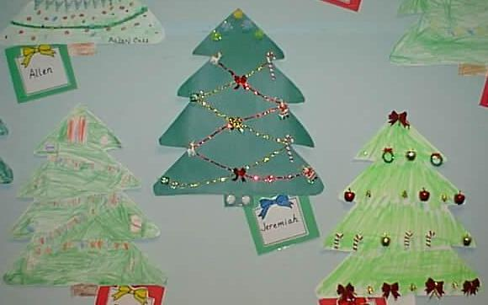

December Family Project
Due: Tuesday December 9th
Hidden Holiday Patterns
Your child's family project for the month of December is to get a jump start on decorating for the holidays!
During the holiday season, we see many brightly decorated trees. Some are trimmed with strands of garland, lights, popcorn and cranberries, and homemade chains. They may be dressed with ornaments of bells, angels, balls, stars, etc.
This month's project asks students and their families to place decorations on the tree in a pattern of their choice. For example....
- strand of lights with an AB pattern (red, yellow, red, yellow)
- ornaments going across in an ABB pattern (star, bell, bell)
Please assist your child in decorating the attached tree using a pattern for each row across. The children can use stickers, foamies, crayons, markers, etc. Students may keep the same pattern throughout (easiest) or they may want to make a different pattern for each row (more challenging). When completed, ask your child to describe the patterns.
When students share their Family Projects with the class, they will point out and tell us their patterns. We will then place all projects in the hall for other classes to search for our 'Hidden Holiday Patterns'!
Enjoy this time with your child!

